Whole Child Behavioral Interventions, Inc.

Cancellations

After Completely filling out the form Email it to [derbywright@wholechildbehavioral.com](mailto:derbywright@wholechildbehavioral.com)

With the subject line of “Cancellation Form” and a body of “Cancellation Form”

|  |  |  |  |  |  |  |  |  |
| --- | --- | --- | --- | --- | --- | --- | --- | --- |
| Client Names: Last, First, M | | | | | Click or tap here to enter text. | | | |
| Client Contact Phone Number | | | | | Click or tap here to enter text. | | | |
| Date of Cancelled Appointments  If more than three add to notes | | | | | Click or tap to enter a date. | Click or tap to enter a date. | | Click or tap to enter a date. |
| Cancellation Reason | | | | Sick  Vacation  Other: Click or tap here to enter text. | | | | |
| Date of Request | | Click or tap to enter a date. | | | | | | |
| Notes | Click or tap here to enter text. | | | | | | | |
| Client Signature: | | |  | | | | DATE | Click or tap to enter a date. |

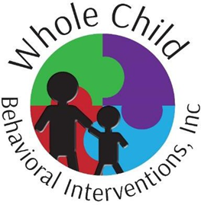

After Completely filling out the form Email it to [derbywright@wholechildbehavioral.com](mailto:derbywright@wholechildbehavioral.com)

With the subject line of “Cancellation Form” and a body of “Cancellation Form”

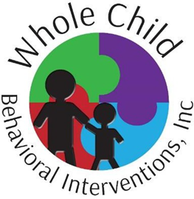

**Cancellations**

Policy: Cancellation of sessions

Purpose: To outline Whole Child Behavioral Interventions guidelines for cancelling ABA sessions for predictable or unpredictable reasons.

Consistency and predictability are an extremely important part of therapeutic sessions. The majority of ABA programs provide intensive direct therapy to clients and require all participants to be present and engaged. The clients initial schedule will be discussed and agreed upon by the scheduling coordinator and the family. Once this schedule is set any long-term changes must be discussed with the scheduling coordinator and agreed upon.

In addition, last minute cancellations can be detrimental to a client’s program. We are aware that unforeseen/unexpected circumstances will arise causing a family or a provider to cancel a session with little or no advance notice. Last minute illnesses, a family crisis, or a vehicle accident are all examples of unforeseen circumstances that may lead to a last-minute cancellation. WCBI reserves the right to change this policy if the client’s family consistently cancels sessions with no advanced notice. We will work directly with a family if this is necessary.

Cancellation of sessions will also be necessary for family vacations, doctor appt., or ongoing illness. Please try to schedule appointments around your agreed upon ABA schedule to avoid canceling sessions. If a cancellation needs to be made for a predictable and/or scheduled reason WCBI requires a minimum of one-week notice. There is a link to the cancellation form on our website (www.wholechildbehavioral.com). This form must be filled out and submitted to derbywright@wholechildbehavioral.com, at least one week prior to the cancellation, in order to avoid being charged a cancellation fee.

In addition, we request that if a client’s family will be taking a vacation that will result in missing more than 3 sessions that they inform the scheduling coordinator and provider at least two weeks prior to the cancellation, using the same cancellation form that can be found on our website (www.wholechildbehavioral.com). This will allow the provider to adjust their schedule and offer services to other families.

If a client’s family chooses to cancel sessions for a predictable reason without giving requested advanced notice, they will be charged a $50.00 cancellation fee. Whole Child Behavioral Interventions will charge families the cancellation fee at their discretion. This cancellation policy is an effort to ensure consistent and predictable services are provided. Cancellations by either party are disruptive to a child’s program and should be kept at a minimum when possible. Advance notice allows the provider to be available to provide services to another child/family.